1)make firebase project, add firestore database  
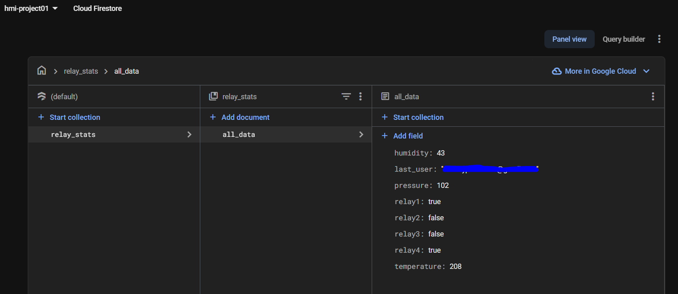  
  
2) in the addon folder, inside the godot-firebase folder, edit the .env file with the project information  
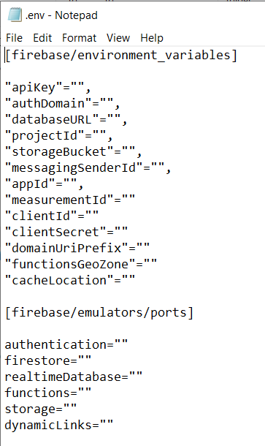  
  
now your project will be working…